Group No: A7 | | Week No: 5 | | Date: 20/07/2026
Autonomous Sea Beach Garbage Cleaning Robot

Component’s Bought:-
In this week, we bought most of the components form the market. We went to the Patuatuli and searched for the exact component and found out most of them but coulden’t find out some components. Here are the component name and their eta and vouchers:-

Components List
SL No | Component Name | Quantity | Unit Price (BDT) | Amount (BDT)
1 | Raspberry Pi 5 4gb ram | 1 | 1300 | 1300
2 | Lead Solder Iron | 1 |  | 260
3 | Bit (Soldering Bit) | 1 |  | 60
4 | Round 100Ω Resistor | 1 |  | 210
5 | BTS-7960 Motor Driver | 2 | 380 | 760
6 | Ultrasonic Sensor | 2 | 65 | 130
7 | PIR Sensor | 2 | 65 | 130
8 | MG-995R 360° Servo Motor | 5 | 330 | 1650
9 | ON/OFF Switch | 4 | 5 | 20
10 | Flux Paste | 1 |  | 160
11 | LM324 IC (verify from invoice) | 1 |  | 900
13 | 130 mm Wheel | 4
14 | 11.1V 5200mAh LiPo Battery | 1 |  | 4200
15 | 16 AWG Silicone Wire | 2 m | 80 | 160
16 | 37GA 300 RPM DC Gear Motor | 4 | 820 | 3280
17 | Cutter | 1 |  | 220

Difficulties:
- Many required components were not available in a single electronics market, so we had to visit multiple shops
- Some components were out of stock, causing delays.
- Heavy traffic jams in the city made traveling between markets time-consuming and exhausting.
- A few components had limited availability, requiring us to wait for new stock or search for alternative suppliers.
- Some electronic components were only available through online sellers, which increased delivery time.

Arm Update:-

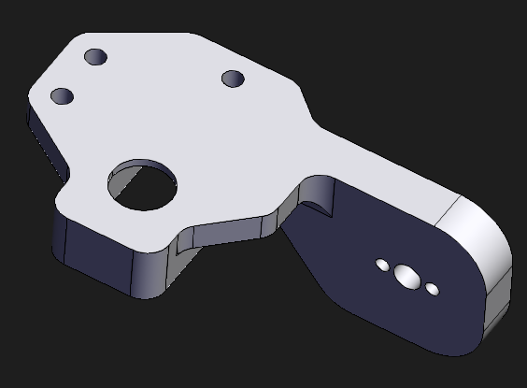
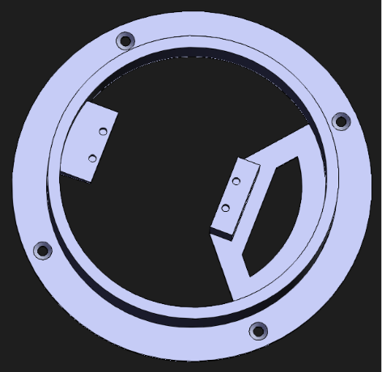
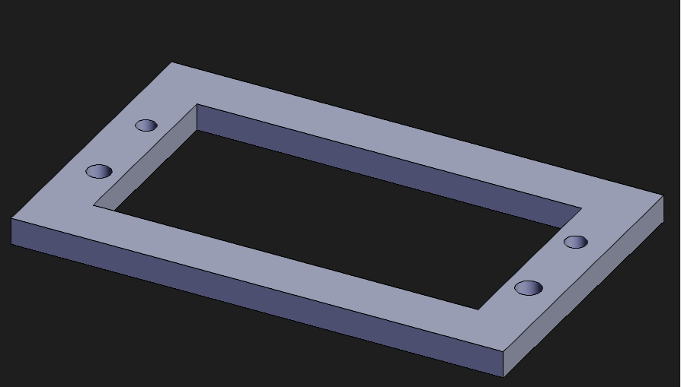
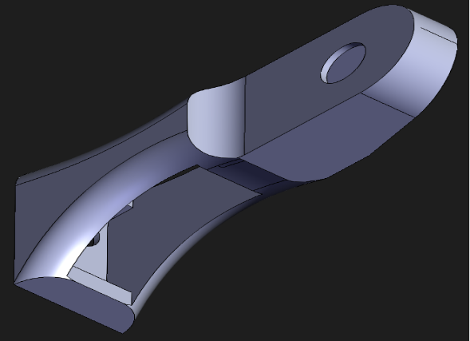
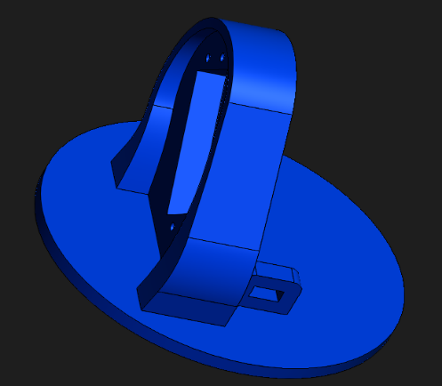
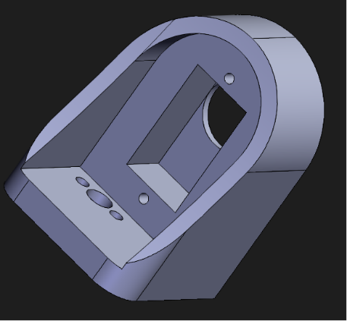
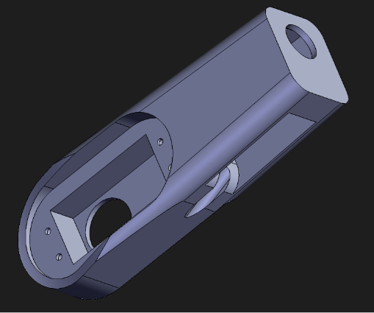
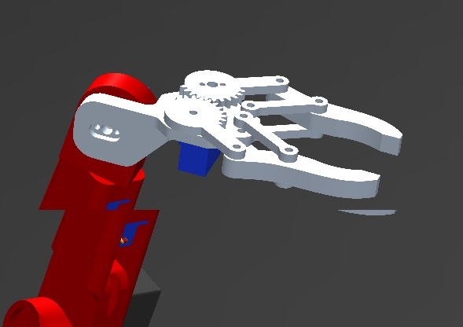
This week, we also modified and designed a robotic arm for garbage collection on the sand scattered garbage pile.

The parts from the Arm are given below:-
.

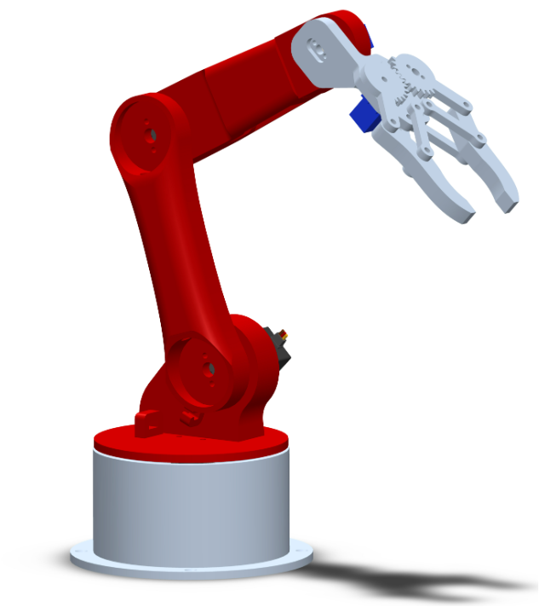
Final Design:-

Difficulties:
- Initially we had no idea about the arm.
- Selection of write motor for the arm was quite difficult as the motor has to produce the torque to hold, move the whole arm and the garbage.
- Coulden’t use a 360 sarvo motor as it doesen’t lock to any angle.
- Have to 3d print the arm out.
- Coulden’t find metal base for the arm.

Setting Up Raspberry Pi 5:
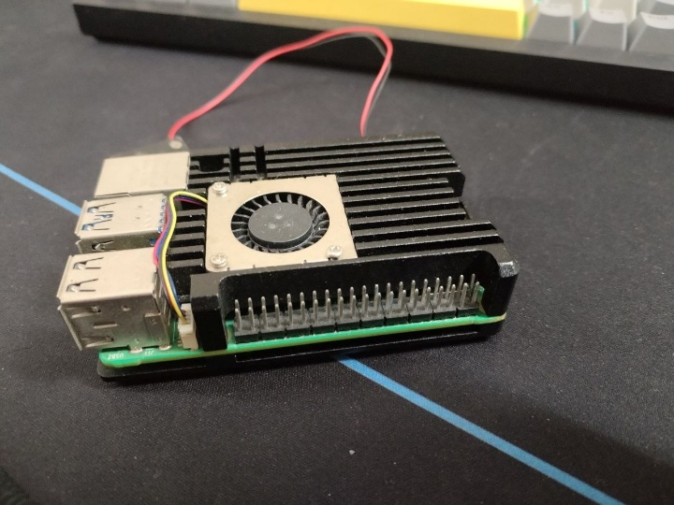
We bought Pi 5 4gb variant for our garbage type detection and as main brain of the rover. We flashed it with Pi os with kde plasma desktop environment.

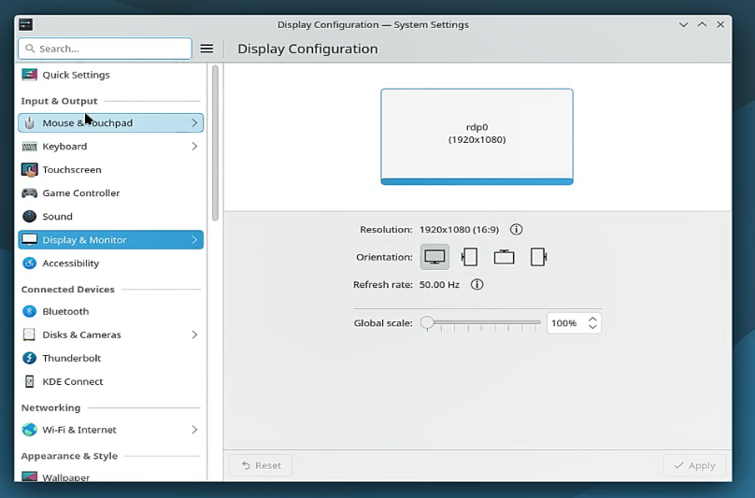
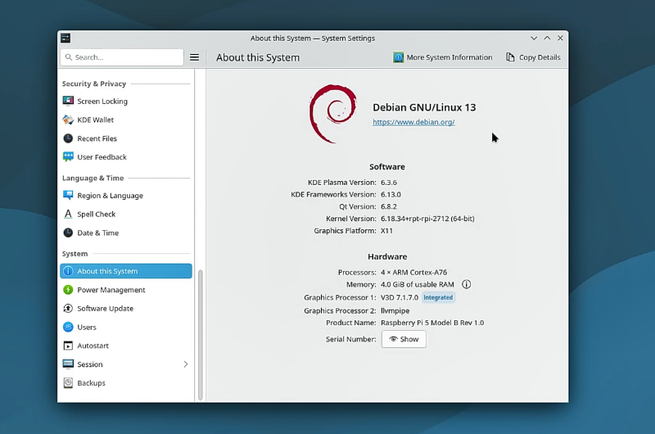
Device and os specification:

Device-
Specification | Details
Device Name | Raspberry Pi 5 Model B Rev 1.0
Processor | Quad-core ARM Cortex-A76 (4 Cores)
CPU Architecture | 64-bit ARM
Clock Speed | Up to 2.4 GHz
Memory (RAM) | 4 GB LPDDR4X
Graphics Processor | VideoCore VII (V3D 7.1.7.0)
Secondary Graphics Driver | llvmpipe (Software Rendering)
GPIO Pins | 40-pin GPIO Header
Connectivity | Gigabit Ethernet, Wi-Fi, Bluetooth 5.0/BLE
USB Ports | 2 × USB 3.0, 2 × USB 2.0
Display Output | Dual Micro-HDMI (Supports up to 4K)
Storage | microSD Card (OS Storage)
Power Supply | 5V DC via USB Type-C

OS-
Specification | Details
Operating System | Debian GNU/Linux 13
Desktop Environment | KDE Plasma
KDE Plasma Version | 6.3.6
KDE Frameworks Version | 6.13.0
Qt Version | 6.8.2
Linux Kernel Version | 6.12.34+rpt-rpi-2712 (64-bit)
Graphics Platform | X11
System Architecture | 64-bit
Default Webpage | https://www.debian.org/

Difficulties:
- Initially, selecting the appropriate operating system for the Raspberry Pi 5 was challenging due to the availability of multiple Linux distributions and desktop environments.
- We had to flash pi os for 4 times to get it working (-_-)
- Configuring SSH, remote desktop access, and network settings required additional troubleshooting and testing.
- Some software packages and libraries were not available by default and had to be installed manually.
- Driver and package updates were necessary to ensure all hardware components functioned correctly.
- 4 rounds of testing and software adjustments were required before the Raspberry Pi operated reliably as the central controller of the robot.

